**Supporting Information**

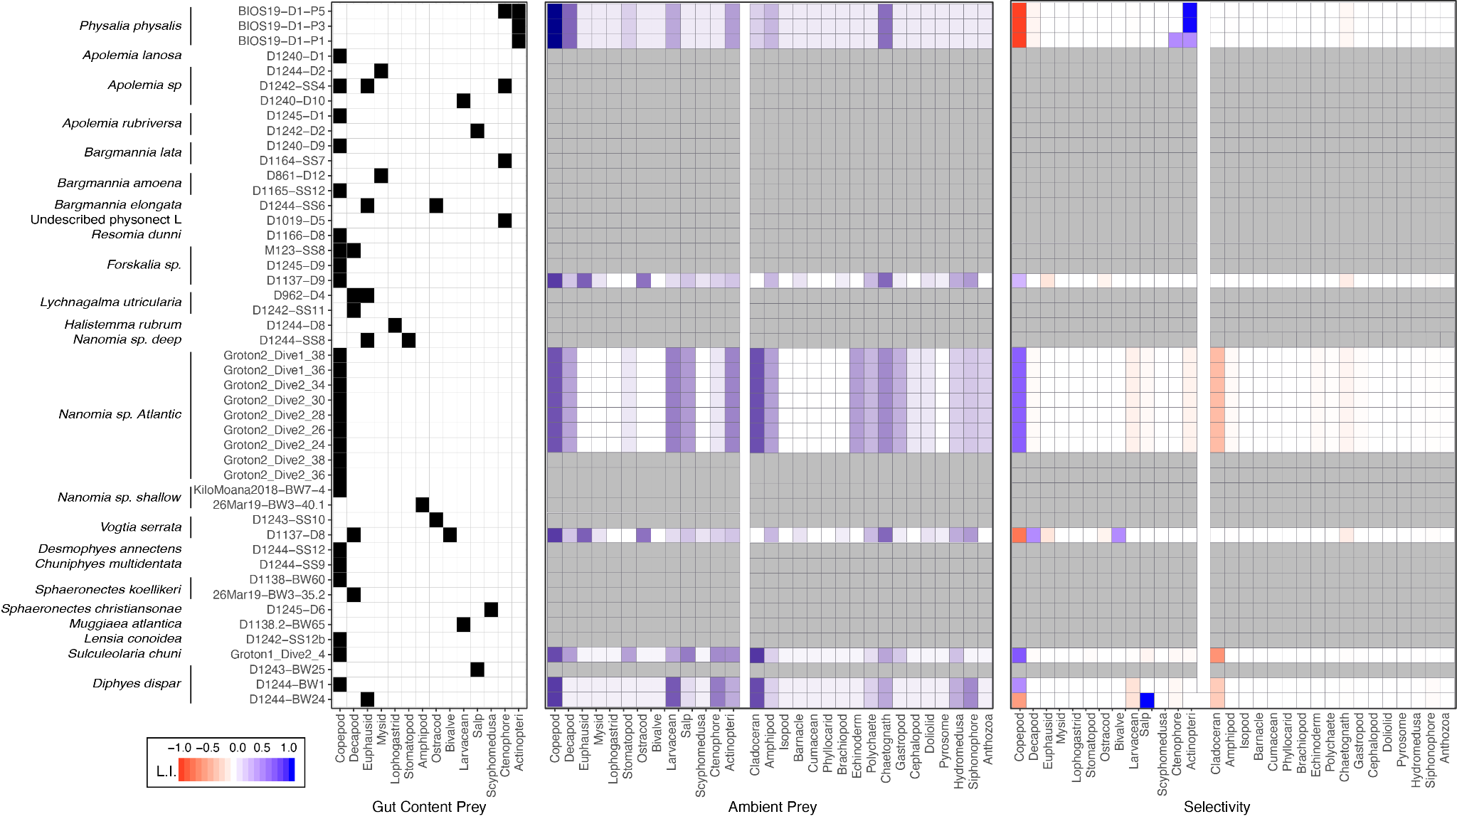

SM-Figure 1. Species-wise grid with the frequency of the major prey types identified from the metabarcoding data (left) and the average prey-type selectivity estimated in comparison with the local planktonic community composition (right). Gut content cells in white indicate absence, and cells in grey indicate presence in one specimen, or more than one specimen if labeled with a number. Selectivity colors mapped to Strauss’ L.I. values.

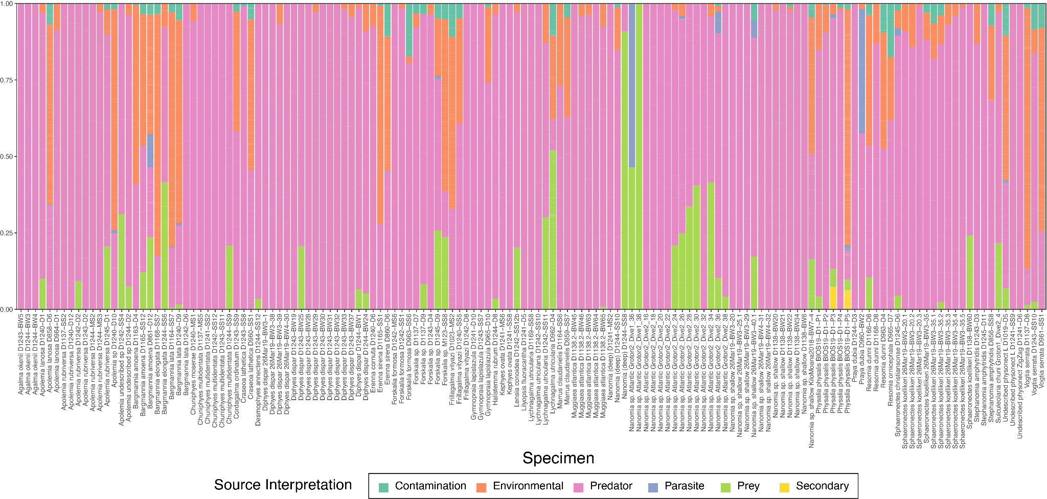

SM-Figure 2. Relative read log-abundance colored by OTU source interpretation for each species.

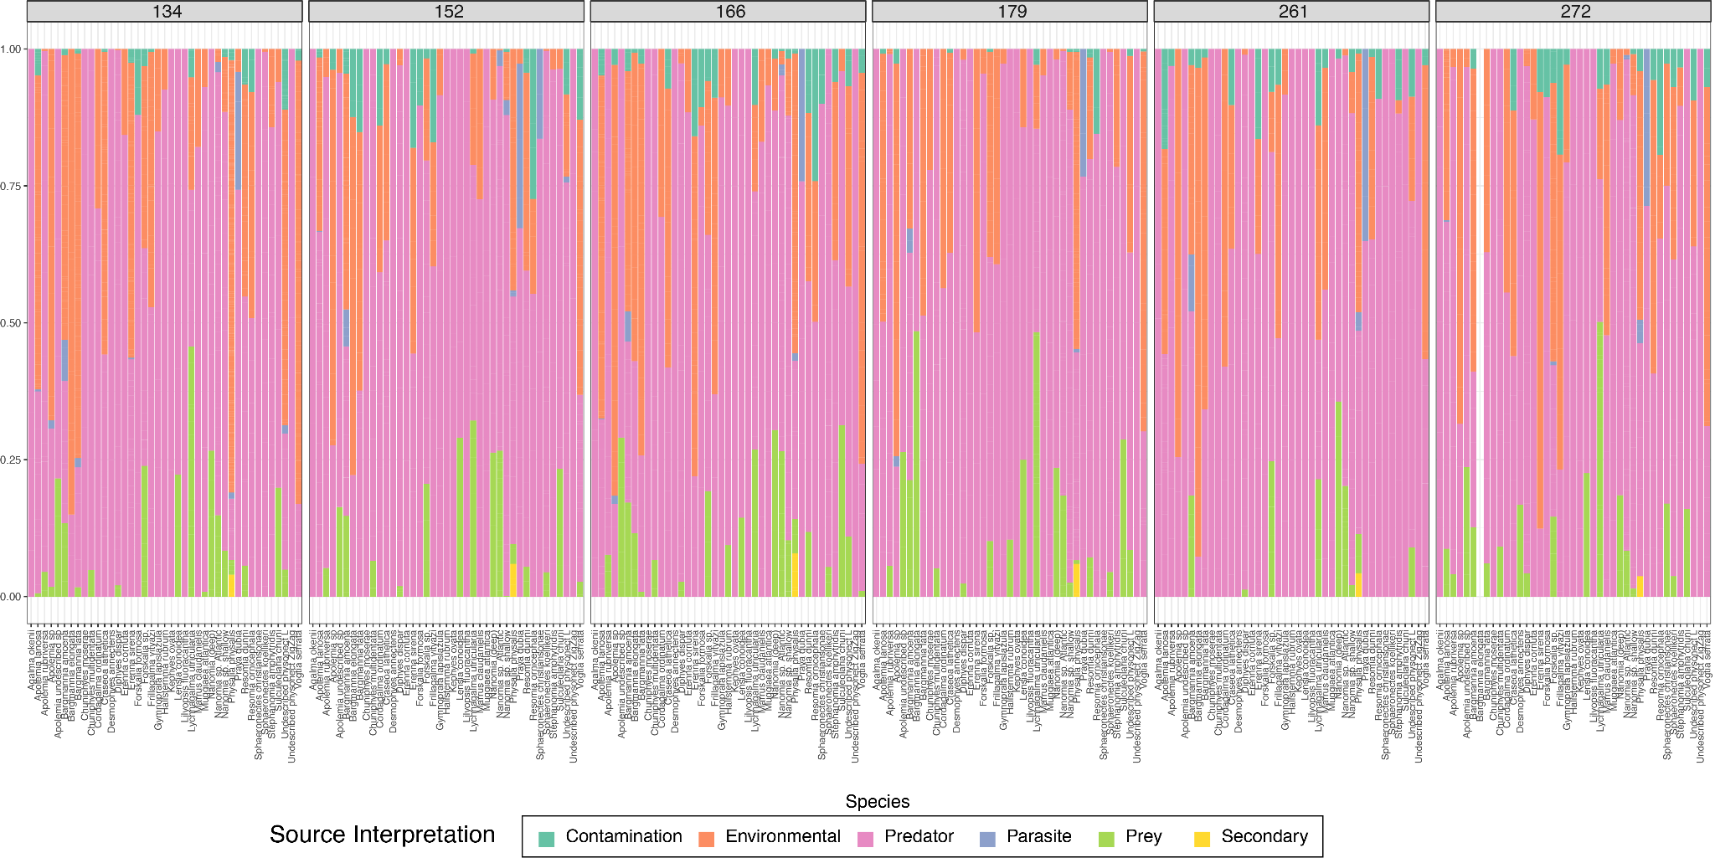

SM-Figure 3. Relative read log-abundance colored by OTU source interpretation for each species and barcode region.



SM-Figure 4. Relative read log-abundance colored by OTU source interpretation for each specimen.

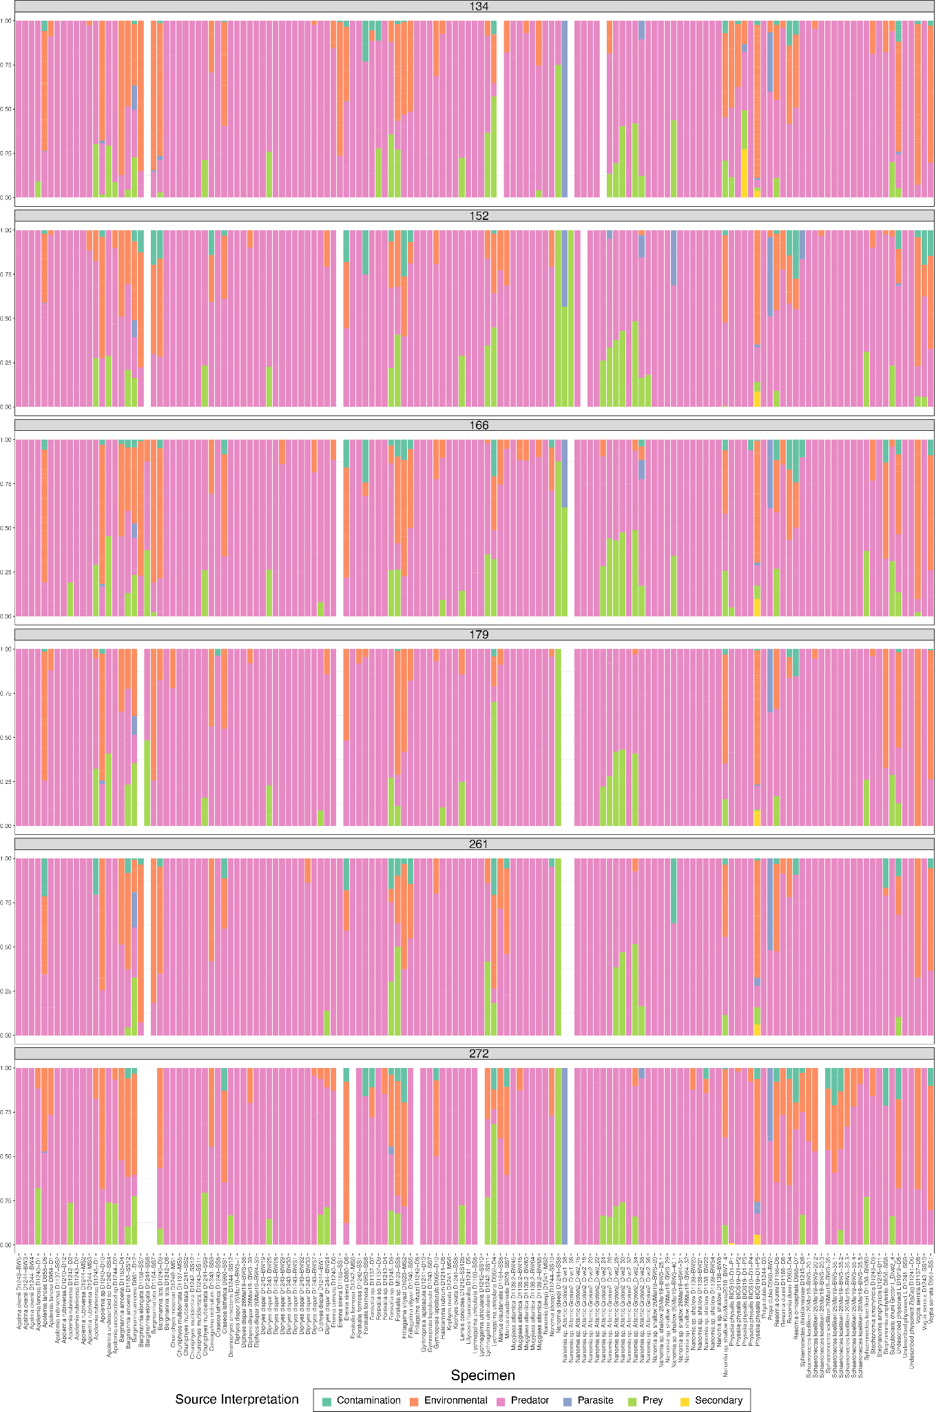

SM-Figure 5. Relative read log-abundance colored by OTU source interpretation for each specimen and barcode region.

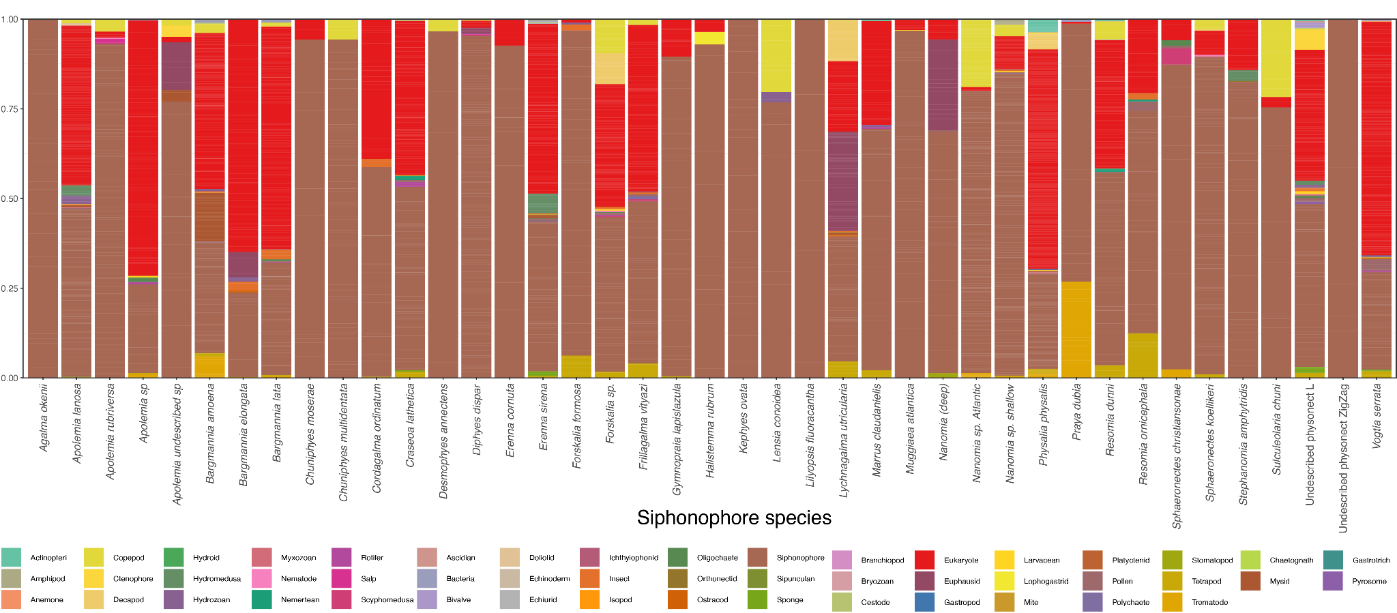

SM-Figure 6. Relative read log-abundance colored by OTU taxon for each species.

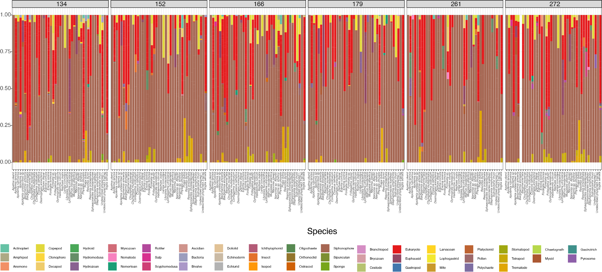

SM-Figure 7. Relative read log-abundance colored by OTU taxon for each species and barcode region.

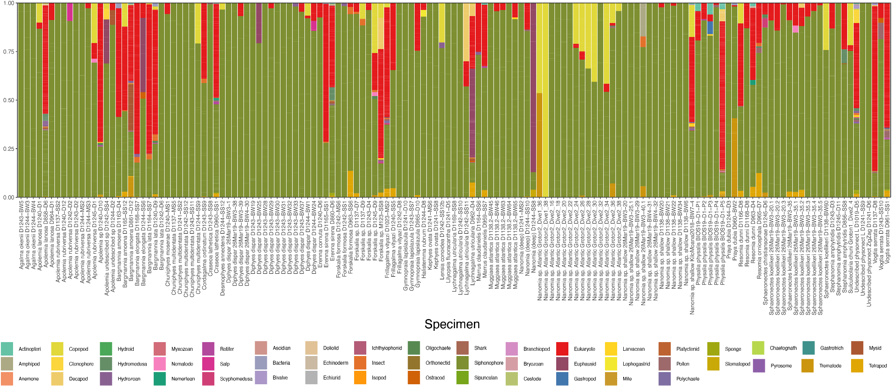

SM-Figure 8. Relative read log-abundance colored by OTU taxon for each specimen.

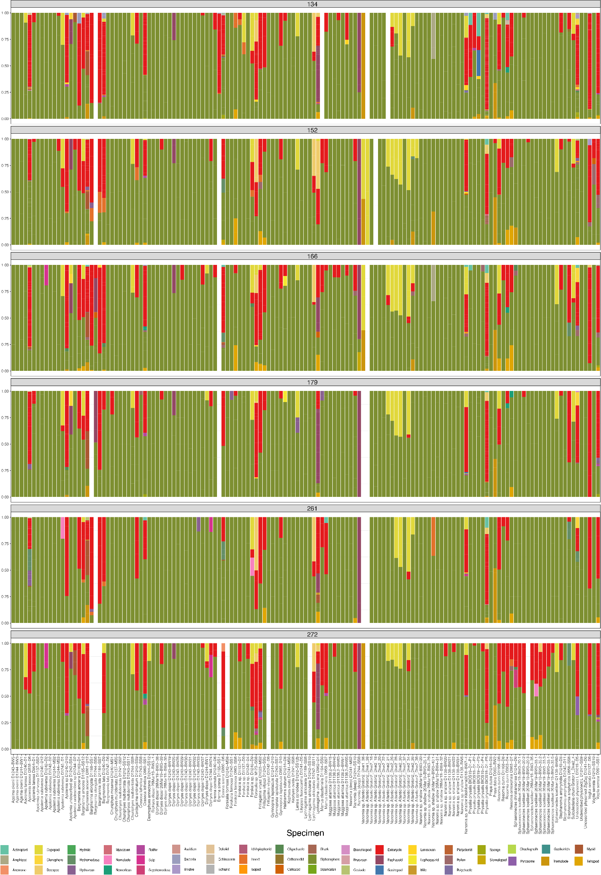

SM-Figure 9. Relative read log-abundance colored by OTU taxon for each specimen and barcode.

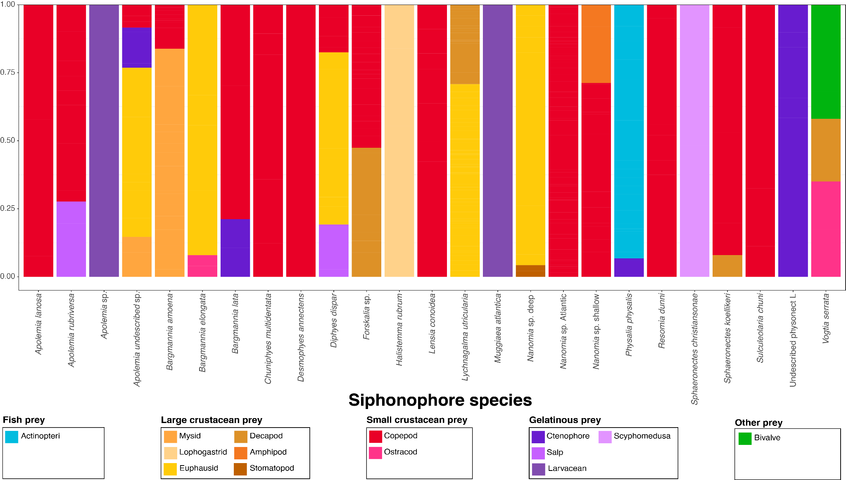SM-Figure 10. Relative read log-abundance of prey colored by prey taxon for each siphonophore species.

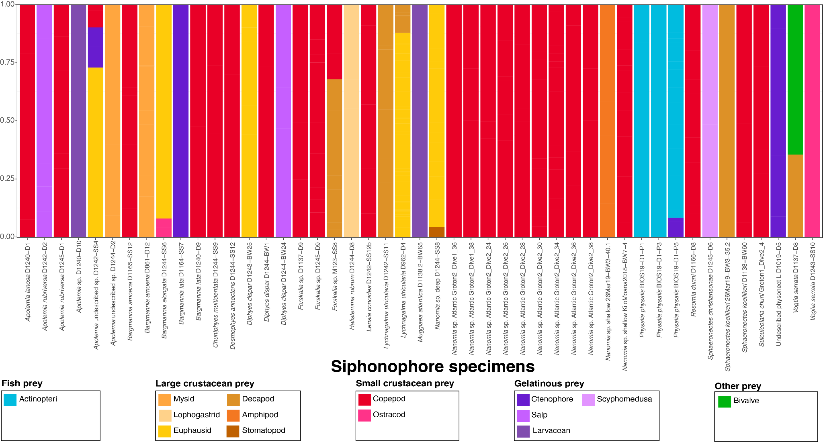

SM-Figure 11. Relative read log-abundance of prey colored by prey taxon for each siphonophore specimen.

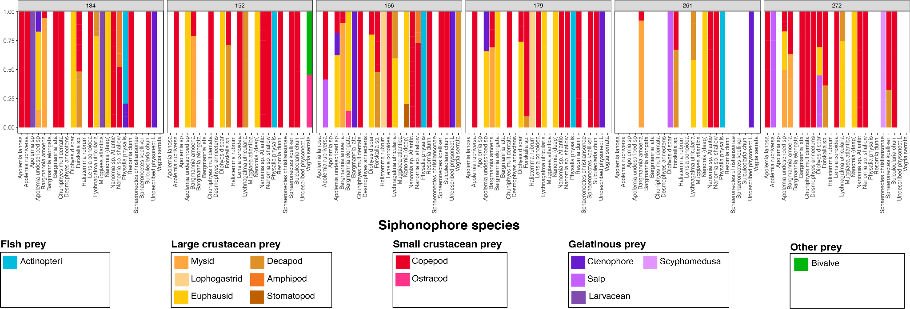

SM-Figure 12. Relative read log-abundance of prey colored by prey taxon for each siphonophore species and barcode.